COMMON COURSE ASSIGNMENT
CSA6502 — GENERATIVE AI AND LARGE-SCALE MODELS | Multimodal Responsible Generative AI Application with Web Deployment

A. Assignment Information
Department | Computer Science and Engineering
Programme | B.E. / B.Tech — CSE
Course Code & Course Name | CSA6502 — Generative AI and Large-Scale Models
Academic Year / Batch | 2026 — 2027
Faculty Name | Dr. Nithisha J
Assignment Title | Design and Implementation of “IndustroSense AI” — A Multimodal Responsible Generative AI Application for Industrial Equipment Diagnostics, integrating RAG, Vector Databases, AI Agents, and Web Deployment
Date of Issue | 01.09.2026
Date of Submission | 02.09.2026
Maximum Marks | 100
Course Outcome(s) — CO | CO3, CO4 & CO5
Bloom's Taxonomy Level | L3 — Apply, L4 — Analyze, L5 — Evaluate, L6 — Create
SDG Mapping (SDG 1–17) | SDG 4 — Quality Education; SDG 9 — Industry, Innovation and Infrastructure; SDG 12 — Responsible Consumption and Production
Industry / Societal Relevance | Multimodal, retrieval-augmented Generative AI assistants are increasingly deployed in manufacturing and industrial settings to support equipment diagnostics, technical documentation, and decision support, combining text, image, and speech understanding while requiring rigorous ethical, security, and governance safeguards before industrial adoption.

1. Problem Statement and Problem Formulation

Industrial equipment such as motors, pumps, compressors, generators, and conveyor systems require regular monitoring and maintenance. Traditional diagnostic methods depend heavily on experienced technicians, equipment manuals, maintenance records, sensor readings, and visual inspection. This can make diagnosis time-consuming and difficult, especially when information is distributed across different documents and data sources.

IndustroSense AI is proposed as a multimodal Generative AI application that assists users in diagnosing industrial equipment problems. The system accepts text queries, equipment images, and sensor/maintenance information, retrieves relevant technical knowledge using Retrieval-Augmented Generation (RAG), stores document embeddings in a vector database, and uses AI agents to perform diagnostic and recommendation tasks.

The system is deployed through a web interface so that users can interact with the diagnostic assistant easily.

2. Objective and Expected Outcomes

Objectives

Develop an AI-based industrial equipment diagnostic assistant.

Support text and image-based inputs.

Implement RAG for retrieving relevant technical information.

Use a vector database for storing and searching document embeddings.

Implement AI agents for diagnostic reasoning and task execution.

Provide responsible and explainable AI responses.

Develop a user-friendly web interface.

Reduce the time required to identify possible equipment problems.

Expected Outcomes

The proposed system should:

Identify possible equipment faults.

Retrieve relevant information from technical documents.

Analyze uploaded equipment images.

Provide possible causes of failure.

Suggest recommended maintenance actions.

Provide supporting references from retrieved documents.

Clearly indicate uncertainty when the AI does not have enough information.

3. Requirements, Constraints and Assumptions

Hardware Requirements

Laptop/Desktop

Minimum 8 GB RAM

Internet connection

Camera or image upload capability

Software Requirements
Software/Technology | Purpose
Python | Main programming language
Streamlit | Web application
LangChain | RAG/AI workflow
Vector Database | Document retrieval
LLM | Generative AI
Embedding Model | Convert documents into vectors
OpenCV/PIL | Image processing
Git/GitHub | Version control

Functional Requirements

User can enter diagnostic questions.

User can upload equipment images.

System can process technical documents.

System can retrieve relevant documents.

System generates diagnostic responses.

System provides maintenance recommendations.

System displays results through a web interface.

Constraints

AI output depends on the quality of available documents.

Incorrect or incomplete sensor data may affect diagnosis.

Image quality can affect visual analysis.

LLM responses may contain errors.

Internet/API availability may affect the application.

Assumptions

Equipment manuals and maintenance documents are available.

Users provide reasonably accurate equipment information.

The system is an assistive diagnostic tool, not a replacement for qualified maintenance personnel.

4. Application of Relevant Course Knowledge / Concepts

This project integrates several AI and computer science concepts:

Artificial Intelligence

Used for automated reasoning and diagnostic assistance.

Generative AI

Used to generate natural-language diagnostic explanations.

Large Language Models

Used to understand user questions and generate responses.

RAG

Retrieval-Augmented Generation combines information retrieval with generative AI.

User Question
↓
Query Processing
↓
Embedding Generation
↓
Vector Database Search
↓
Relevant Documents
↓
LLM
↓
Grounded Diagnostic Response

Vector Database
Technical documents are converted into embeddings and stored in a vector database.
When a user asks a question, the question is also converted into an embedding. Similar documents are then retrieved using vector similarity.

AI Agents
Agents can be designed to perform specialized tasks such as:
- Equipment identification
- Document retrieval
- Fault analysis
- Maintenance recommendation
- Safety checking

Multimodal AI
The system can process different forms of information:
- Text
- Images
- Sensor values
- Technical documents

5. Design / Proposed Solution / Methodology

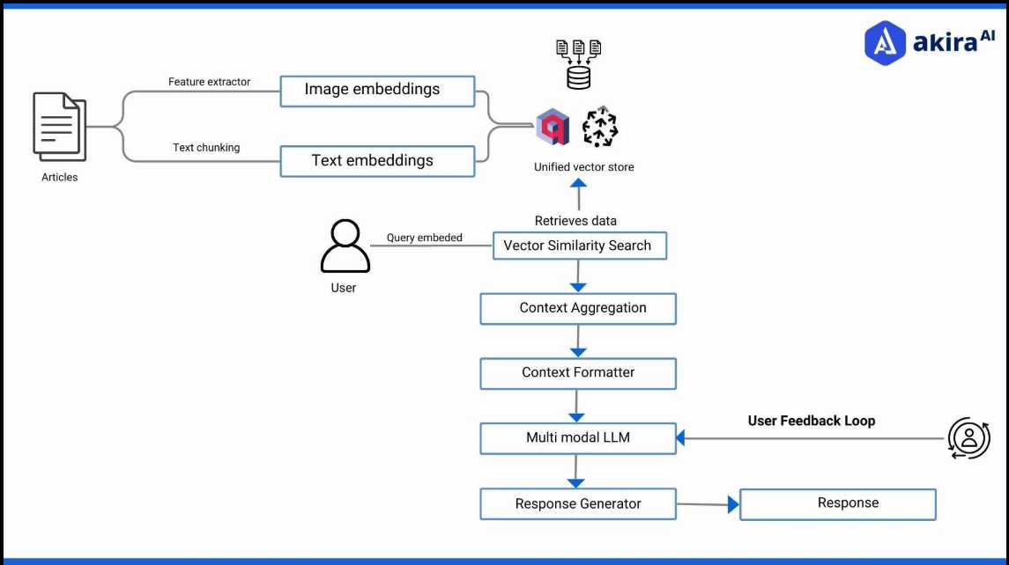

Proposed Architecture

┌─────────────────────┐
│ User │
└──────────┬──────────┘
↓
┌─────────────────────┐
│ Streamlit Web UI │
└──────────┬──────────┘
↓
┌──────────────────────┐
│ Multimodal Input │
│ Text + Image + Data │
└──────────┬───────────┘
↓
┌─────────────────────┐
│ AI Agent Layer │
└──────────┬──────────┘
↓
┌──────────────┼──────────────┐
↓ ↓ ↓
Image Analysis RAG Retrieval Sensor Analysis
│ │ │
│ ┌──────▼──────┐ │
│ │Vector DB │ │
│ └──────┬──────┘ │
│ ↓ │
│ Technical Docs │
└──────────────┼──────────────┘
↓
┌───────────────┐
│ LLM │
└───────┬───────┘
↓
┌─────────────────────┐
│ Diagnostic Response │
│ • Possible Fault │
│ • Causes │
│ • Evidence │
│ • Recommendation │
│ • Safety Warning │

6. Algorithm / Pseudocode / Flowchart

Algorithm
- Start the application.
- Load technical documents.
- Split documents into smaller chunks.
- Generate embeddings.
- Store embeddings in the vector database.
- Accept user input.
- Determine whether input contains text, image, or sensor data.
- Process the input.
- Generate a search query.
- Retrieve relevant documents.
- Pass retrieved context to the AI agent/LLM.
- Generate a diagnostic response.
- Perform responsible-AI checks.
- Display diagnosis and supporting information.
- End.

Pseudocode

START

Load technical documents

FOR each document:
Extract text
Split text into chunks
Generate embeddings
Store embeddings in Vector Database

User enters query
User may upload equipment image
User may provide sensor information

Analyze user input

IF image is provided:
Perform image analysis

Generate query embedding

Search Vector Database

Retrieve relevant technical information

Send:
User Query
Retrieved Context
Image Analysis
Sensor Data

to AI Agent

AI Agent analyzes the information

Generate:
Possible Fault
Possible Causes
Recommended Actions
Supporting Evidence
Safety Warning

Perform Responsible AI validation

Display response

END

7. Implementation / Source Code and Environment / Tools Used

Development Environment
Operating System : Windows 11
Language : Python
IDE : VS Code / Python IDLE
Web Framework : Streamlit
AI Framework : LangChain
Vector Database : FAISS / Chroma
LLM : Generative AI model
Image Processing : PIL / OpenCV
Version Control : Git/GitHub

9.Analysis, Comparison, Trade-offs and Justification

Feature | Traditional Diagnosis | IndustroSense AI
Manual document search | Required | Automated
Text-based assistance | Limited | Yes
Image analysis | Manual | Supported
Knowledge retrieval | Manual | RAG
Vector search | No | Yes
AI agents | No | Yes
Web access | Limited | Yes
Response speed | Moderate/Low | High
Human involvement | High | Reduced
Explainability | Expert-dependent | Retrieved evidence can be shown
Trade-offs
Advantages:
- Faster information retrieval.
- Multimodal interaction.
- Centralized technical knowledge.
- Can operate as a 24/7 assistant.
- Reduces repetitive diagnostic work.
Trade-offs:
- Requires good technical documentation.
- LLM/API costs may occur.
- AI can produce incorrect conclusions.
- Vector database requires proper document preparation.
- Human verification is still necessary for safety-critical decisions.

12. Broader Considerations / SDG Relevance

SDG 9 – Industry, Innovation and Infrastructure
IndustroSense AI supports intelligent industrial infrastructure by applying AI and automation to equipment monitoring and maintenance.

SDG 12 – Responsible Consumption and Production
Early identification of equipment problems can help prevent unnecessary equipment failure, material wastage, and inefficient operation.

Responsible AI
The system should:
- Clearly communicate uncertainty.
- Avoid claiming guaranteed diagnoses.
- Provide evidence for generated answers.
- Protect uploaded industrial data.
- Include safety warnings.
- Keep humans involved in critical maintenance decisions.

13. Conclusion, Limitations and Possible Improvements

Conclusion
IndustroSense AI demonstrates how multimodal Generative AI can be applied to industrial equipment diagnostics. By combining RAG, vector databases, AI agents, multimodal inputs, and web deployment, the system provides users with an intelligent interface for retrieving technical information and generating diagnostic assistance.
The proposed system can reduce the time required to search maintenance documents and provide structured information about possible equipment faults. However, the system should be treated as a decision-support tool rather than a replacement for qualified industrial technicians.

Limitations
- Diagnostic accuracy depends on the quality of the knowledge base.
- LLM hallucination is possible.
- Image analysis may fail with poor-quality images.
- Limited datasets may reduce reliability.
- Internet/API dependency may affect availability.

Future Improvements
- Real-time IoT sensor integration.
- Predictive maintenance.
- Digital-twin integration.
- Voice-based interaction.
- More advanced computer vision.
- Automated maintenance scheduling.
- Mobile application.
- Edge-AI deployment.
- Integration with industrial SCADA/IoT systems.

14. Individual Contribution of Group Members
Example:
Member | Contribution
Member 1 | RAG and document processing
Member 2 | Vector database and embeddings
Member 3 | AI agent development
Member 4 | Multimodal/image processing
Member 5 | Streamlit web deployment and testing
Change these according to the actual work done by each member.

15. References
Your references section can include:
- Python documentation.
- Streamlit documentation.
- LangChain documentation.
- Vector database documentation.
- OpenAI/other LLM API documentation, if used.
- RAG-related research papers.
- Multimodal AI research papers.
- Industrial equipment manuals.
- Datasets used for equipment/defect analysis.
- GitHub repositories used in the implementation.

16. One-Page Individual Reflection
For your individual reflection, cover:
My Role:
Explain which part of IndustroSense AI you developed.
Technical Learning:
Explain what you learned about Python, RAG, embeddings, vector databases, LLMs, AI agents and Streamlit.
Challenges:
Mention problems such as API errors, document retrieval, embedding generation, prompt design, image processing or deployment.
Problem Solving:
Explain how you debugged and improved the system.
Teamwork:
Explain how responsibilities were divided among team members.
Overall Learning:
Explain how the project helped you understand the practical application of Generative AI in industrial environments.
Future Improvement:
Explain what you would improve if given more time.

